4/5/2023

Mark Deyarmond

PROG2007: Final Project

PollSys United

User Guide Document

### Users

If you have been given your username and password by the polling officer, you can proceed with launching the PollSys United voting software. The default landing spot is the main menu where you will need to key in the number 1 to log into the user panel.

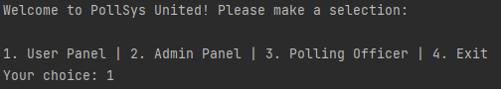

Press enter to proceed to the login screen where you will be prompted for your assigned username and password. Once you’ve entered valid credentials, you will be presented with your choice of 3 candidates.

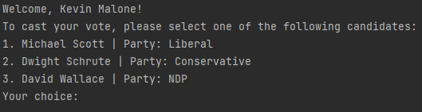

Simply enter a candidate number to cast your vote and your session will be terminated after the vote processes. You will land back at the main menu where you can press 4 to exit.

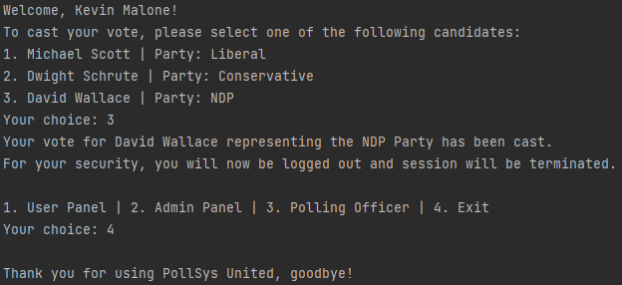

### Admin

If you have been given access to the Admin Panel, use the option 2 on the main menu. You will need to enter your valid credentials to gain access to the Admin Panel.

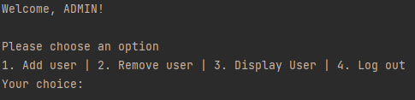

When you have gained access to the Admin Panel, you will see 4 options. Choosing to add a user prompts the admin to enter some details about the user so they can be put on the voters list. If user is not 18 years of age, the user’s information will be destroyed and not added to the voters list.

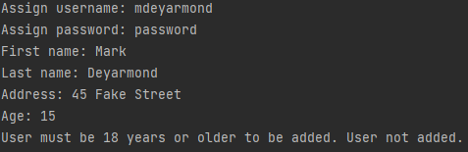

You can also choose to remove a user with option 2, simply enter the username to be removed and the user is erased from the database. If there is no such user in the database, PollSys will display a message saying so.

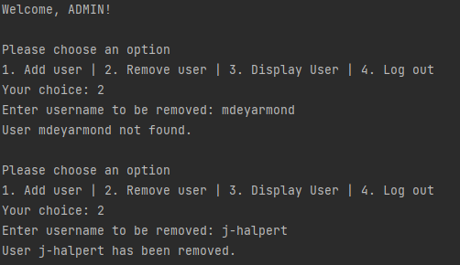

Lastly, you can display a list of all registered voters by selecting option 3 in the Admin Panel.

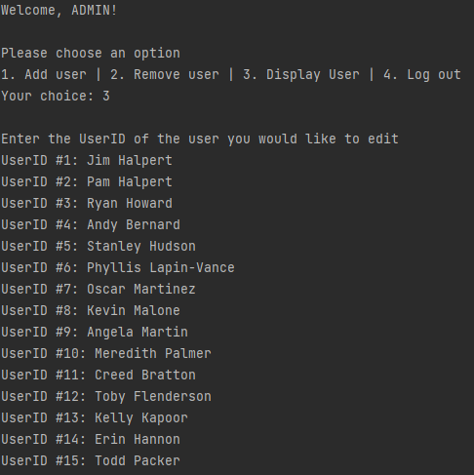

### Polling Officer

The polling officer is the one who has access to the vote count to ensure no interference. Default credentials for polling officer are as follows:

Username: POLLSYS-T1 Password: dummypass

Use these credentials to get into and view the polling count. It is highly recommended to change these credentials before deployment in the workspace: the current credentials are dummy credentials only.

